**ĐẠI HỌC BÁCH KHOA HÀ NỘI**

**TRƯỜNG CÔNG NGHỆ THÔNG TIN VÀ TRUYỀN THÔNG**

*******************

**THỰC HÀNH LẬP TRÌNH HƯỚNG ĐỐI TƯỢNG**

**Giảng viên hướng dẫn:** Lê Thị Hoa

Tên sinh viên:

Đoàn Thanh Tùng

MSSV: 20225946

Contents

BÁO CÁO THỰC HÀNH LAP 1 2

The Very First Java Programs 2

*2.2.1* Write, compile the first Java application: 2

2.2.2 Write, compile the first dialog Java program 2

2.2.3 Write, compile the first input dialog Java application 3

2.2.4 Write, compile, and run the following example: 4

BÀI TẬP 6

2.2.5 Write a program to calculate sum, difference, product, and quotient of 2 double numbers which are entered by users. 6

BÁO CÁO THỰC HÀNH LAP 1

# The Very First Java Programs

## *2.2.1* Write, compile the first Java application:

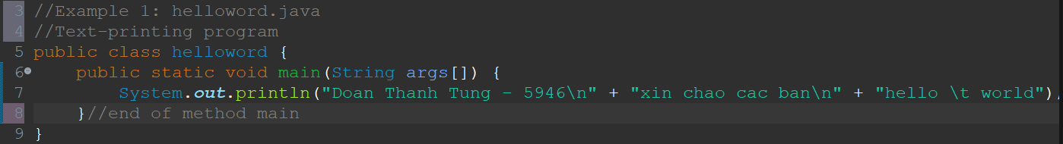

*Kết quả:*

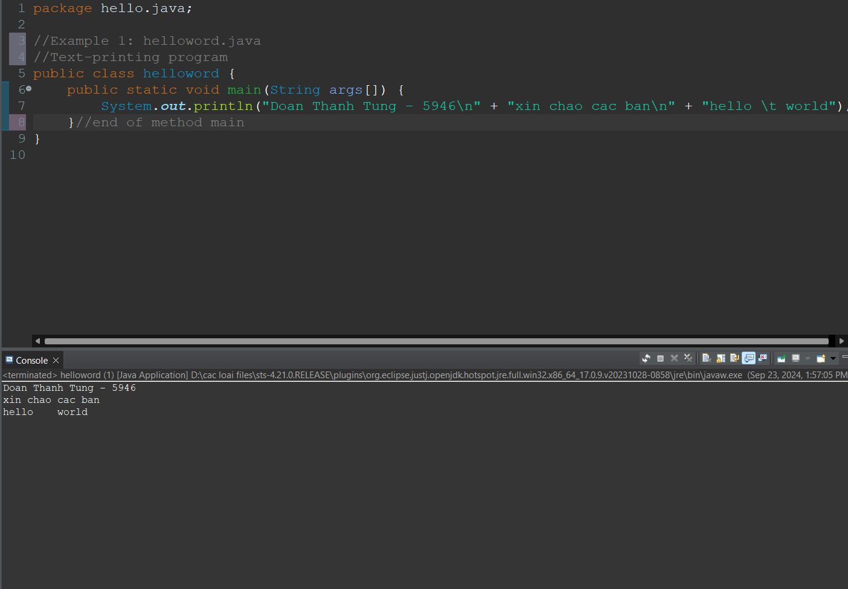

## 2.2.2 Write, compile the first dialog Java program

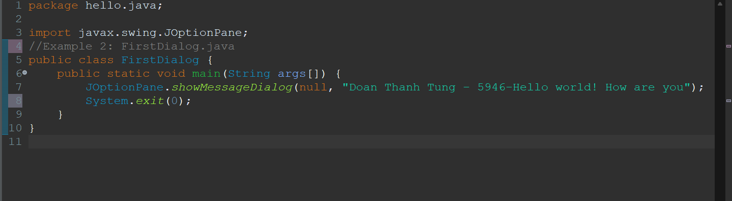

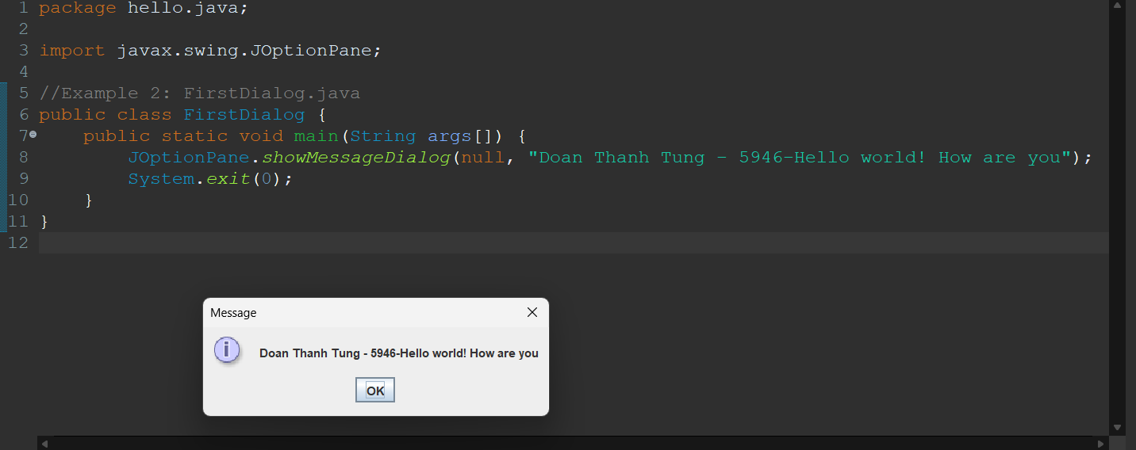

## 2.2.3 Write, compile the first input dialog Java application

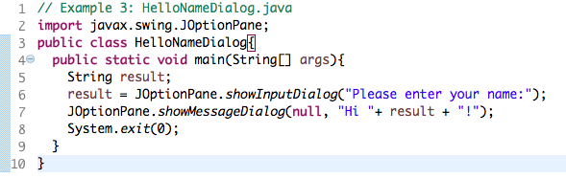

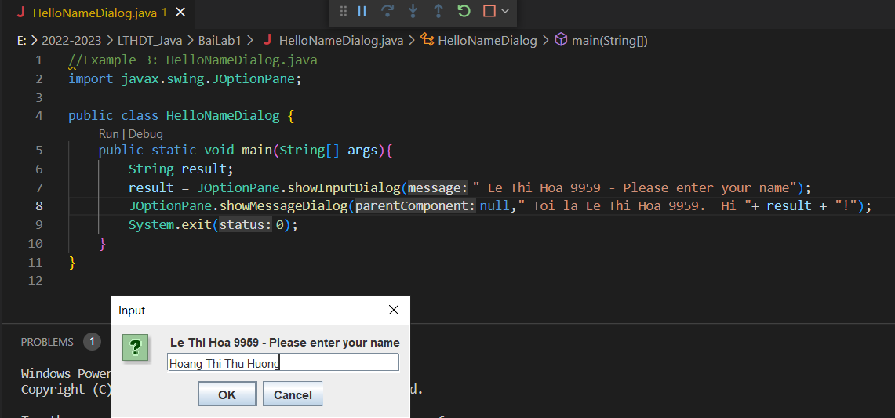

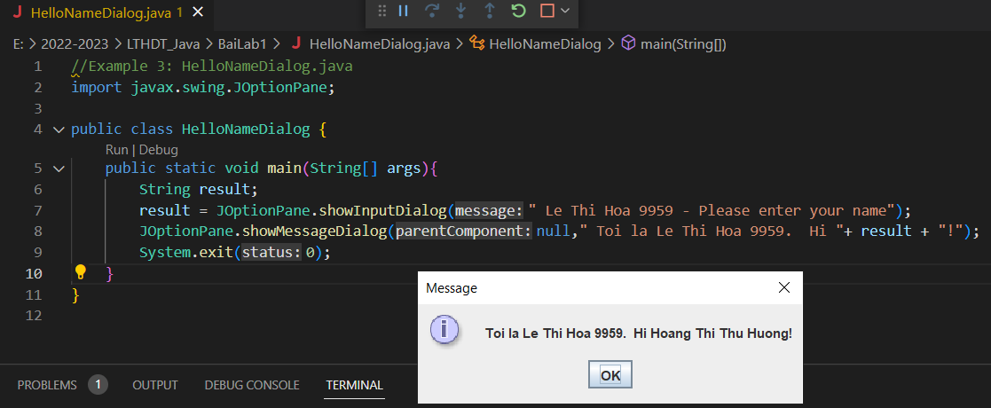

## 2.2.4 Write, compile, and run the following example:

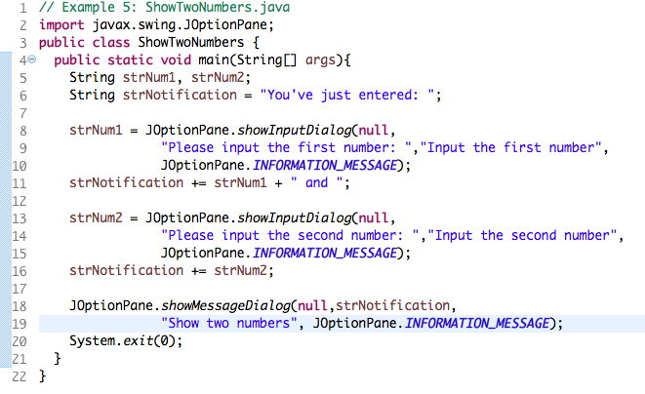

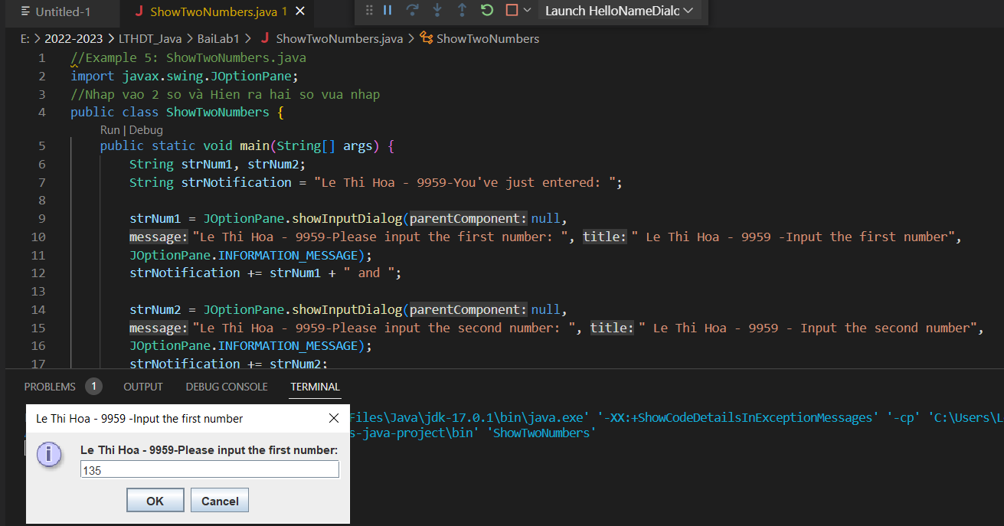

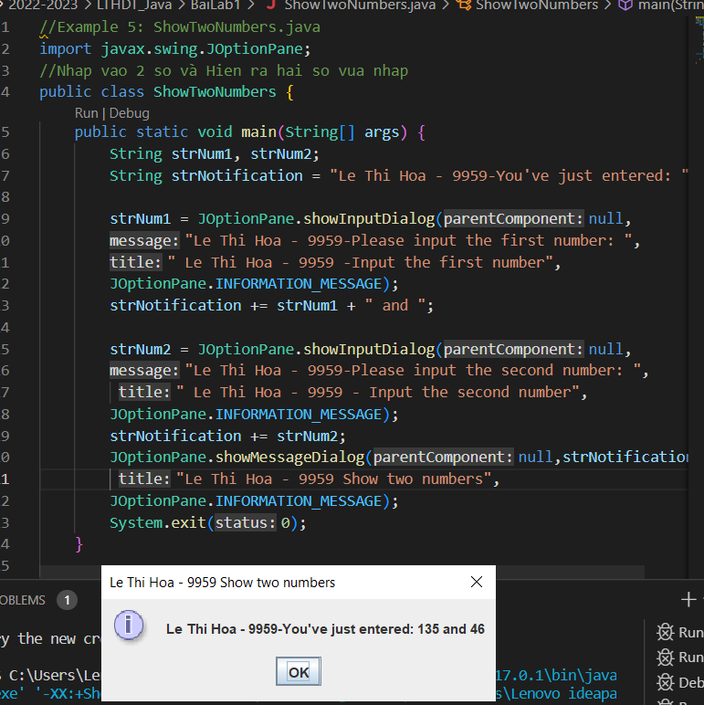

# BÀI TẬP

## 2.2.5 Write a program to calculate sum, difference, product, and quotient of 2 double numbers which are entered by users.

**Notes**

* To convert from String to double, you can use

**double num1 = Double.parseDouble(strNum1)**

* Check the divisor of the division
  + 1. ….